Lab No-11

Lab Report Name: Implementation of FIFO page replacement algorithm .

Objectives:

- What is FIFO page replacement algorithm.
- How to implement?

Theory:
In this algorithm, a queue is maintained. The page which is assigned the frame first will be replaced first. In other words, the page which resides at the rare end of the queue will be replaced on the every page fault.In this algorithm, the operating system keeps track of all pages in the memory in a queue, the oldest page is in the front of the queue. When a page needs to be replaced page in the front of the queue is selected for removal.

Example:

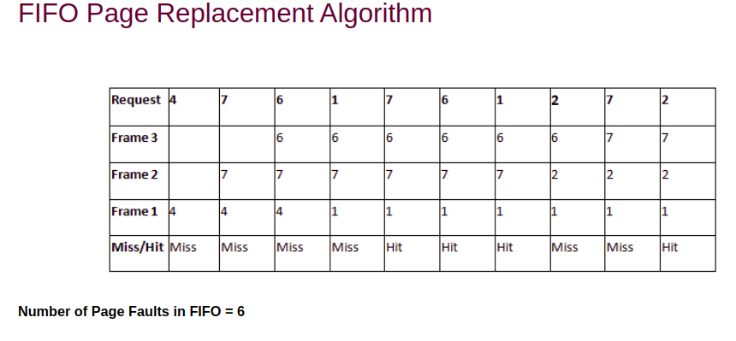

C program to implement FIFO page replacement algorithms:

#include<stdio.h>
int main()
{
int i,j,n,pagenumber[50],frame[10],numberofFrames,k,avail,count=0;
printf("Enter the number of Pages: ");
scanf("%d",&n);
printf("Enter the page number : ");
for(i=1; i<=n; i++)
scanf("%d",&pagenumber[i]);
printf("Enter the number of FRAMES : ");
scanf("%d",&numberofFrames);
for(i=0; i<numberofFrames; i++)
frame[i]= -1;
j=0;
printf("\n");
printf("reference string\t page frames\n");

for(i=1; i<=n; i++)
{
printf("%d\t\t",pagenumber[i]);
avail=0;
for(k=0; k<numberofFrames; k++)
if(frame[k]==pagenumber[i])
avail=1;
if (avail==0)
{
frame[j]=pagenumber[i];
j=(j+1)%numberofFrames;
count++;
for(k=0; k<numberofFrames; k++)
printf("%d\t",frame[k]);
}
printf("\n");
}
printf("Page Fault is: %d",count);
printf("\n");
return 0;
}

output:
